Shay Bites Dust as Crowd Bites Dogs

There was tragedy on the B.B. & F.R. R.R. Saturday Sept. 8 as the railroad entertained dignitaries at their annual get-together. While everyone was enjoying a good time and cook out the railroads prime mover, Shay #5, was shuffling freight up and down the grade. While CEO Beck was visiting with the crowd and eating a hot dog the news came, “the Shay went off the cliff.” Without hesitation Beck dropped his plate and libation and rushed to the scene. A crowed had gathered as Beck rushed forward to restore order in what seemed total confusion. Fortunately there were no serious injuries except the pride of the track maintenance crew. The incident is being blamed on some shoddy track bed work.

Beck said, “We have been plagued throughout the recent year with a deteriorating road grade in this area.” Mr. R. Loving, a railroad expert who was attending the event, said “The grade seemed to be excessively skewed.” Beck went on to say, ”Many trains have been lumbering up and down the line all day and most likely the dirt ballast gave way, making the track lean over a bit to much.” The disarray was tidied up very quickly. The cars never left the rails and were rolled down on their own concurrence to meet up with a 2-8-0 consolidated. A crew was dispatched, some time after the 2-8-0 took up duties, to repair the grade. This was done under the direction of Mr. Loving. It seemed to some it was the same old shoddy work. Beck promises the run from the high bridge to the Y will get a major overhaul in the not to distant future.

Desserts were served after the incident and enjoyable time was had by all. C. Yonker took over train operations with his capable assistant Anthony, no other incidents were reported. The desserts were plentiful and varied; they ranged from pumpkin pie to ice cream sundaes. About 8 PM the remaining guests were entertained with the classic movie “The General.” A large screen was setup and the movie started. This is a wonderful railroad movie staring Buster Keytone. It was released in 1927 and is black and white and silent, except for a wonderful music accompaniment. The crowd loved this tale of a Southern railroad engineer who’s locomotive and girl friend were stolen be Northern spies during the Civil War. Where was lots of railroad action in this comedy as Keytone tries to get both of them back. There was applause at the end as he was of course successful on both accounts.

The party broke up about 9:30 and a grand time was had by all. The B.B. & F.R. R.R. has a great bi thanks to all who attended. Beck says we will try it again with a rebuild of the lines roadbed in a first class manner.
Photos tell the story…

the wreck of Locomotive #5 on Sept. 8 during the festivities at the B.B. & F.R. R.R. open house.

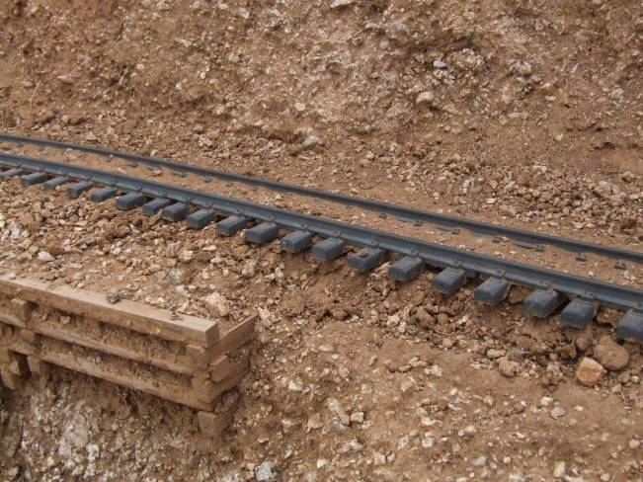

Where the Shay came to rest, towage still on the rails above.

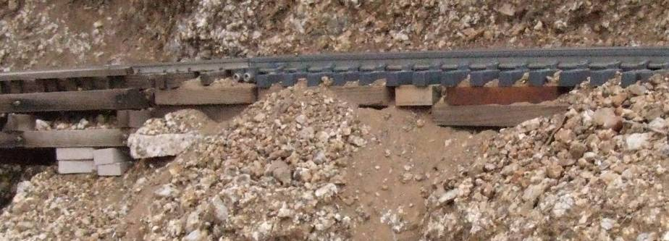
The engineer, visible in the cab,
was shaken up but uninjured.

Shoddy and sub standard track work was the blame.
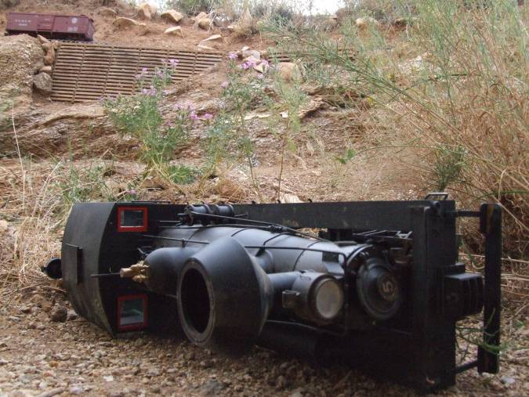
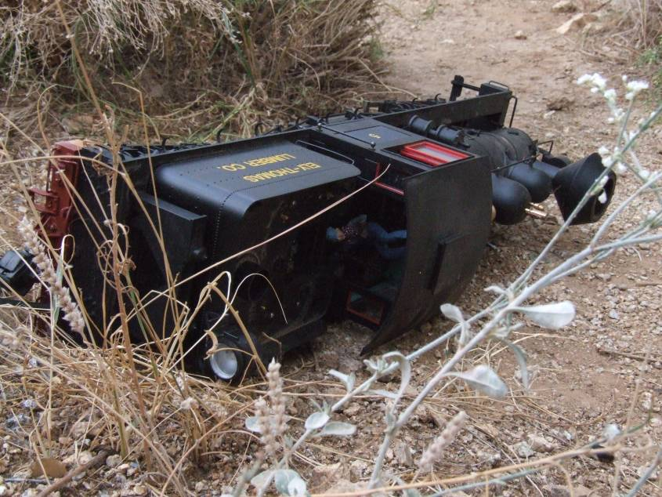
Shay #5 will be put back in service after some lengthy repairs.

